Thomas Tallis School

Assignment title | Culture Sculpture for Greenwich Market
Assessor
Date issued
Duration (approx)
Hand in Date |  | Assessment Date
Qualification suite covered | BTEC NQF Level 2 First Award in Art and Design
Units covered | Unit 4: Communicating Ideas in 3D
Learning aims covered | Learning aim A: explore 3D visual language and working practices  Learning aim B: investigate how artists, craftspeople and designers communicate in 3D.  Learning aim C: Communicate ideas using 3D knowledge and skills in response to a brief
Scenario | Greenwich Arts and Crafts Market is celebrating 315 years of being apart of the community and wants Tallis art students to celebrate its diverse local culture. Greenwich Arts and Crafts Market is commissioning you to develop and produce a sculpture inspired by culture to be sold on a stall at the Market.
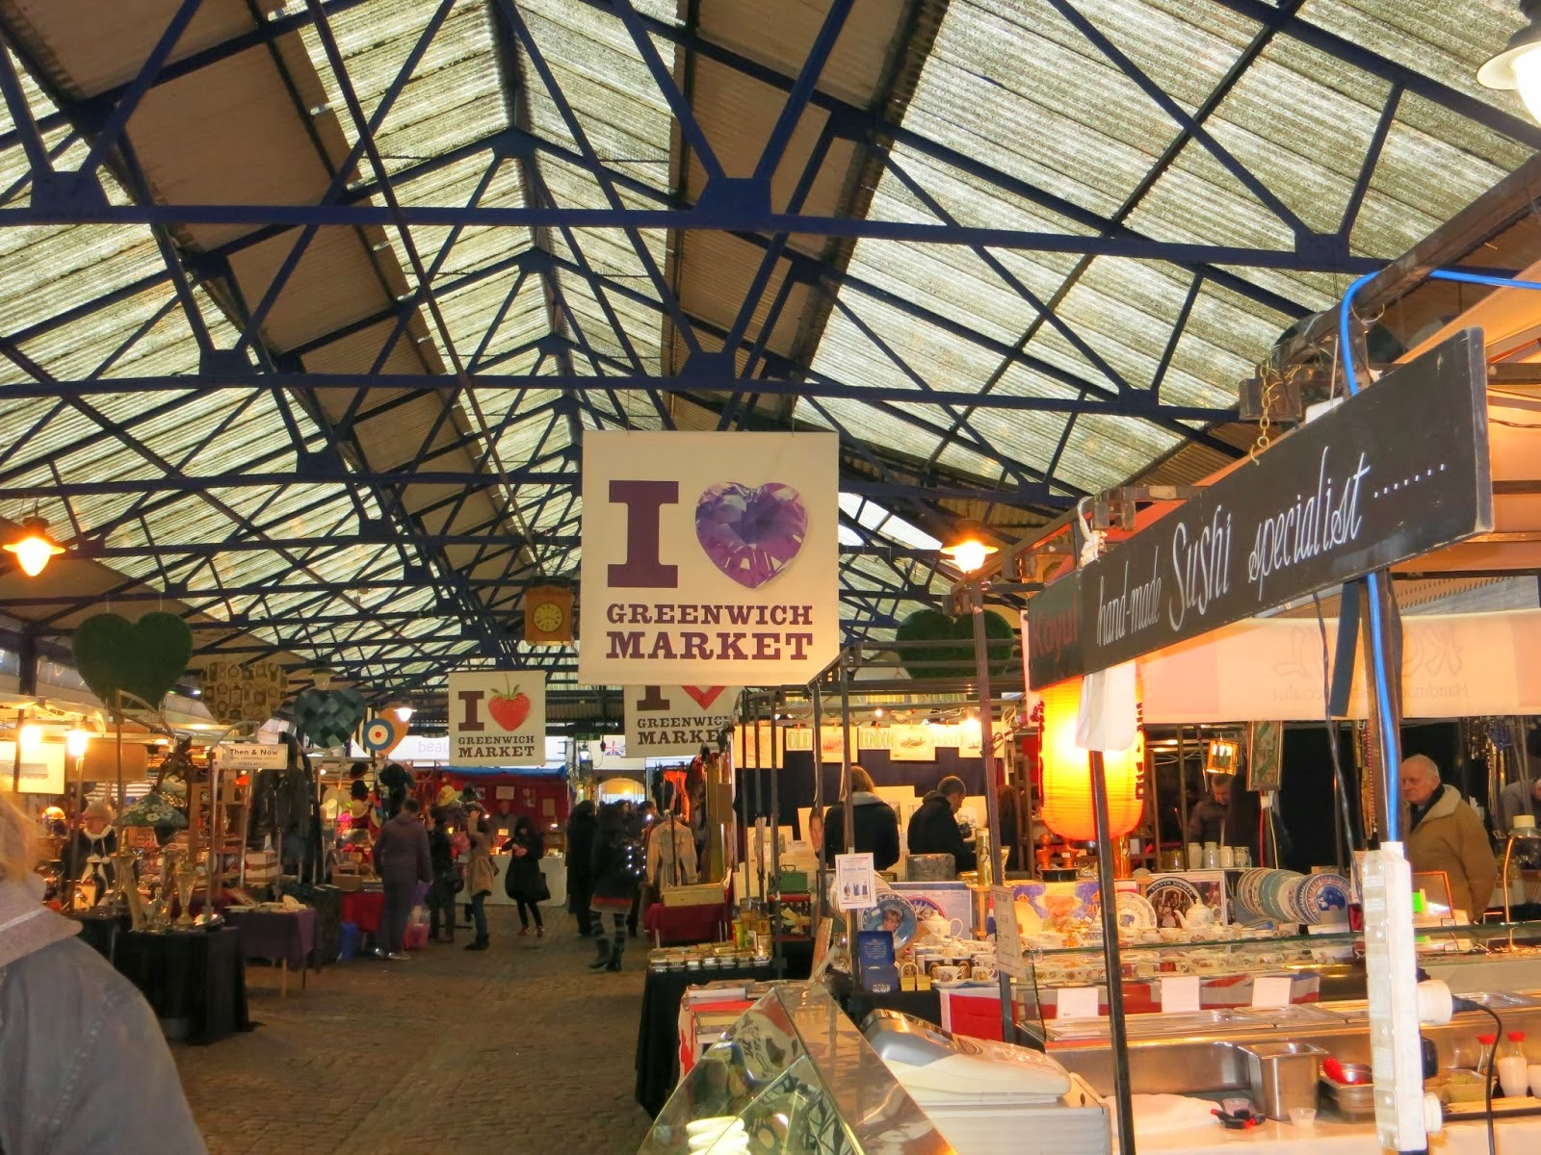

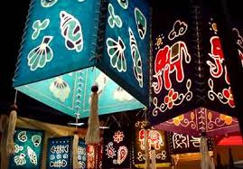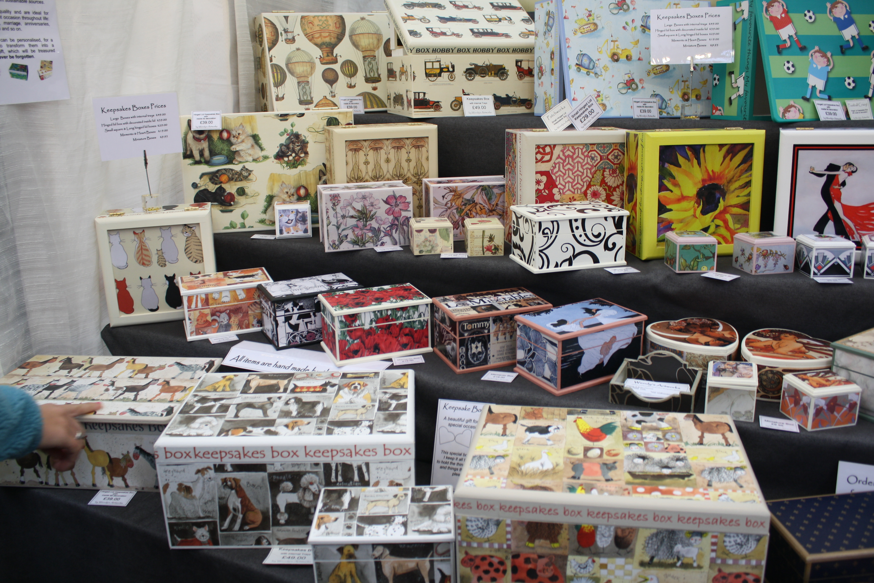
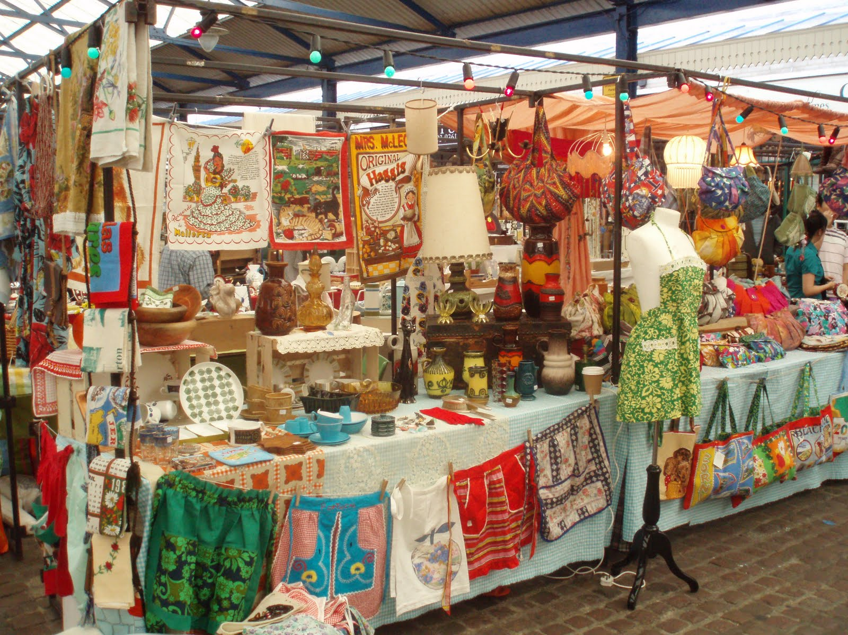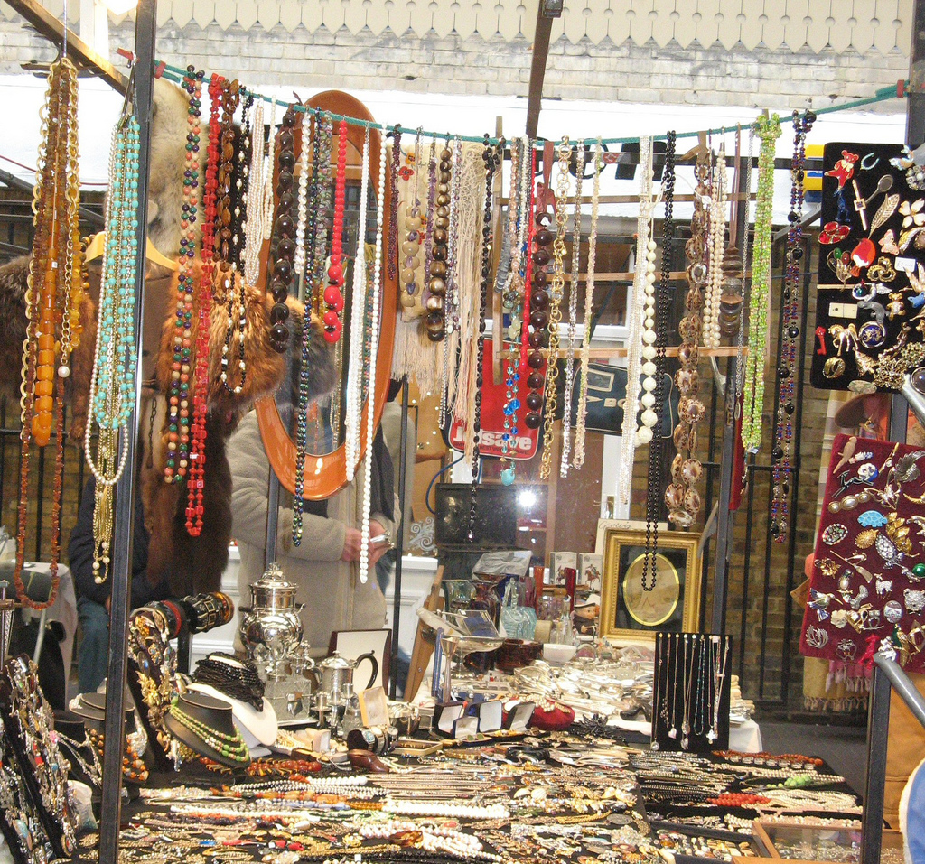

Task 1 | Explore Sculpture and Sculptors  Start by exploring a range of 3D materials and techniques through experimentation. Investigate forming shapes and construction techniques and testing limitations of each material. Materials should include (but restricted to) paper, card, wire, clay, plaster, tights etc  Compare advantages and disadvantages of using different materials eg strength, weight, malleability, flexibility, safety etc. Annotate your results, discuss the physical properties and characteristics of each material.  For each material you have explored, investigate a 3D practitioner who uses a similar material or technique. Annotate their use of 3D materials, techniques and ways of communicating.  Compare and contrast the works of 4 3D practitioners illustrating their different approaches  You should demonstrate safe working practice with materials (e.g. scissors, scalpels, glue gun, stapler etc)  You will present your samples to the class, explaining how your ideas developed from your research into artists, and what materials, equipment and techniques you have used.
Evidence you must produce for this task | A sketchbook of 3D developmental work which should contain experiments of different techniques, processes and investigations into a range of 3D practitioners  3D experiments into a range of materials  A verbal presentation of the above work to the class, reviewing your discoveries so far and how your ideas could be developed further
Criteria covered by this task:
To achieve the criteria you must show that you are able to: |  |  | Unit |  | Criterion reference
Apply 3D visual language using materials, equipment and techniques, observing and recording safe working practices. |  |  | 4 |  | 2A.P1
Apply 3D visual language, selecting and using a diverse range of materials, equipment and techniques effectively and with consistency. |  |  | 4 |  | 2A.M1
Apply 3D visual language, combining and using a diverse range of materials, equipment and techniques, creatively and imaginatively. |  |  | 4 |  | 2A.D1
Describe four of the skills and associated materials, techniques and processes required by practitioners working in 3D. |  |  | 4 |  | 2B.P2
Select and present effective investigations into a diverse range of 3D practitioners, explaining how they communicate their ideas. |  |  | 4 |  | 2B.M2
Select and present in-depth investigations into a diverse range of 3D practitioners, analysing how they communicate their ideas. |  |  | 4 |  | 2B.D2
Select and present examples of work by at least four 3D professional practitioners, illustrating their different approaches. |  |  | 4 |  | 2B.P3
Task 2 | Final Piece  Research into at least 2 different cultures and the artwork associated with those cultures. Investigate artists linking to your 2 chosen cultures  Develop 2 ideas inspired by the cultures you have chosen. You will need to produce 2 mock pieces as a practice for your final piece. You will need to consider what materials would be suitable for your idea.  Review and further develop your most successful piece. Continue to experiment with suitable materials for your idea. Document your development throughout using photographs and annotations. Note any change of ideas and any difficulties you have overcome. You will need to consider why this would be a suitable item to go on sale at Greenwich Market? Who would be your target audience? How much would you sell it for?  Produce your final piece in your chosen material
Evidence you must produce for this task | A completed sketchbook recording the progress of your work.  2 mock pieces  Your final sculpture for Greenwich Market  An evaluation of your final piece and use of 3D materials and techniques.
Criteria covered by this task:
To achieve the criteria you must show that you are able to: |  |  | Unit |  | Criterion reference
Communicate ideas using 3D knowledge and skills to generate visual work that meets the requirements of a brief, observing and recording safe working practices. |  |  | 4 |  | 2C.P4
Select and use 3D materials, equipment and techniques to generate a diverse range of visual work that effectively meets the requirements of a brief. |  |  | 4 |  | 2C.M3
Use a diverse range of 3D materials, equipment and techniques to generate a diverse range of visual work that imaginatively meets the requirements of a brief. |  |  | 4 |  | 2C.D3
Record the progress of own work and use of 3D methods. |  |  | 4 |  | 2C.P5
Effectively explain the progress of own ideas and review use of 3D methods. |  |  | 4 |  | 2C.M4
Analyse and evaluate the progress of own ideas and use of 3D methods. |  |  | 4 |  | 2C.D4
Sources of information | References  Relevant artists:  Anish Kapoor Alberto Giacometti  Anthony Gormley Constantin Brancusi  Fischli and Weiss Ron Mueck  Al Weiwei Richard Serra  Anthony Gormley Sarah Lucas  Richard Deacon Anish Kapoor  Damien Hirst Auguste Rodin  Marc Quinn Constantin Brancusi  Claes Oldenburg Eva Hesse  Edgar Dagar Orozco  Picasso Henri Moore  Gaudi Rachel Whiteread  Richard Long Tara Donovan  William Kentridge Martin Senn  Johnson Tsang Richard Sweeney  Relevant books:  Patrick Bade (2008) 1000 Sculptures of Genius  Gombrich, EH (1950) ‘The Story Of Art’ – Chapter 27: Experimental Art  Glenn Halper (2010) A Sculpture Reader: Contemporary Sculpture Since 1980  Jac Scott (2003) Textile Perspectives in Mixed-Media Sculpture  Relevant Websites:  www.sculpture.org/  www.tate.org.uk/collections/glossary/definition.jsp?entryId=267  www.guardian.co.uk/artanddesign/sculpture  www.jennyfordsculpture.com/  www.textilescapes.co.uk/portfolio2.html  www.thetrendboutique.co.uk/sculptural-fashion-pieces-by.../a  https://www.pinterest.com/machum/yr-10-3d/
If you have not achieved the Level 2 criteria, your work will be assessed to determine if the following Level 1 criteria have been met.
To achieve the criteria you must show that you are able to: |  |  |  | Unit |  | Criterion reference
Apply 3D visual language with a limited range of materials, equipment and techniques using safe working practices. |  |  |  | 4 |  | 1A.1
Identify how artists, craftspeople and designers communicate in 3D. |  |  |  | 4 |  | 1B.2
Present at least two examples of 3D professional practitioners, identifying the chosen artists, craftspeople and designers. |  |  |  | 4 |  | 1B.3

