Thomas Tallis School

Assignment title | Growth and/or Decay Art Exhibition
Assessor
Date issued
Duration (approx)
Hand in Date |  | Assessment Date
Qualification suite covered | BTEC NQF Level 1/2 First Award in Art and Design
Units covered | Unit 1: Introduction to specialist pathways
Learning aims covered | Learning aim A: use specialist materials, techniques, equipment and processes in response to client briefs  Learning aim B: record formal elements within specialist pathways.
Scenario | Thomas Tallis Art and Design Department is commissioning you to develop and produce a piece of art based on the theme of Growth and/or Decay to be showcased in the annual Tallis Art exhibition in April 2017. Your response could be in either 2D, 3D or digital media.
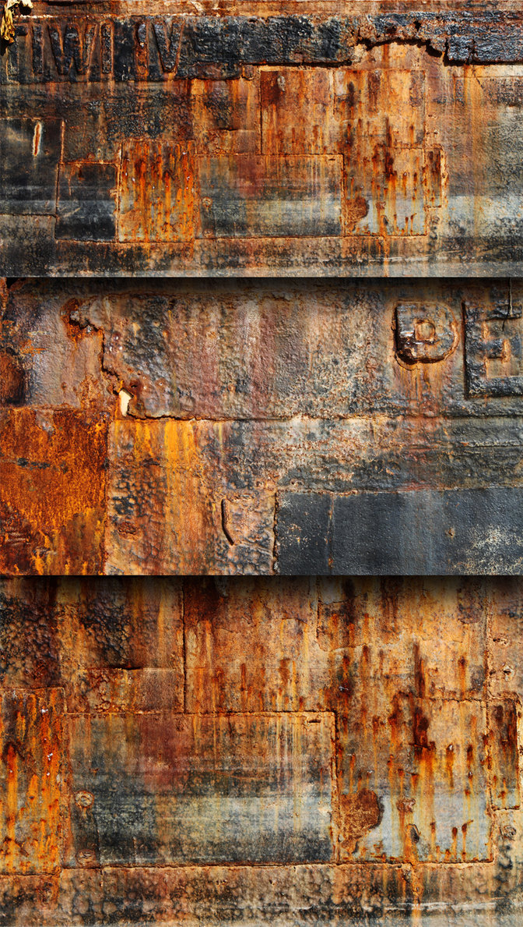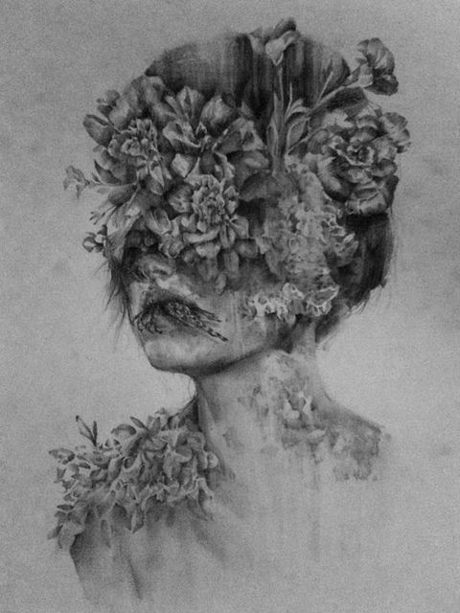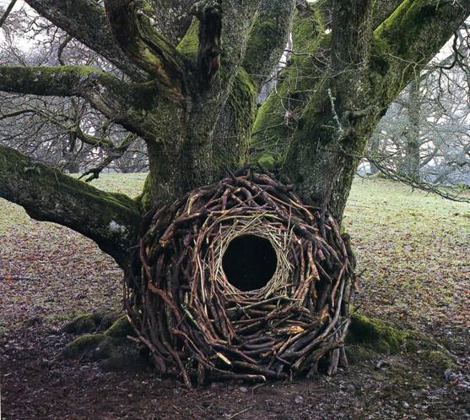
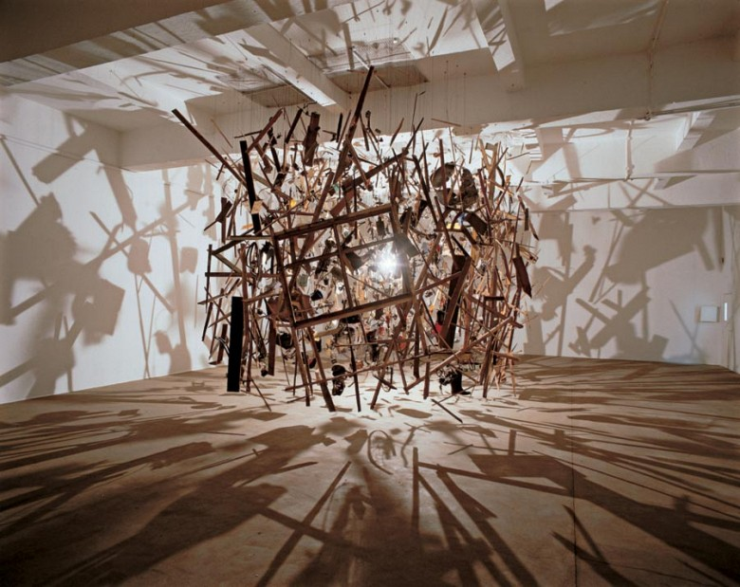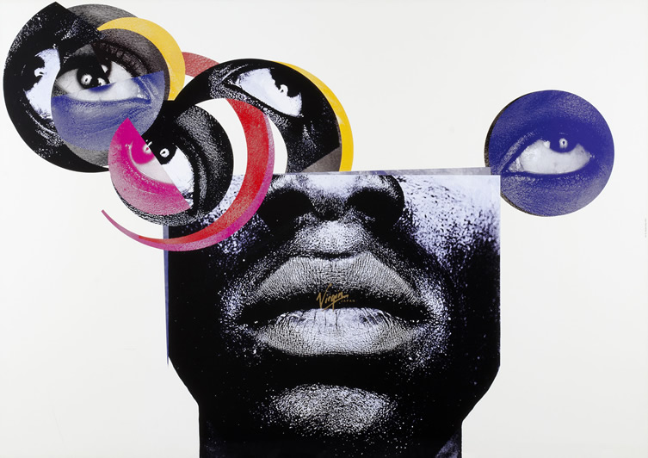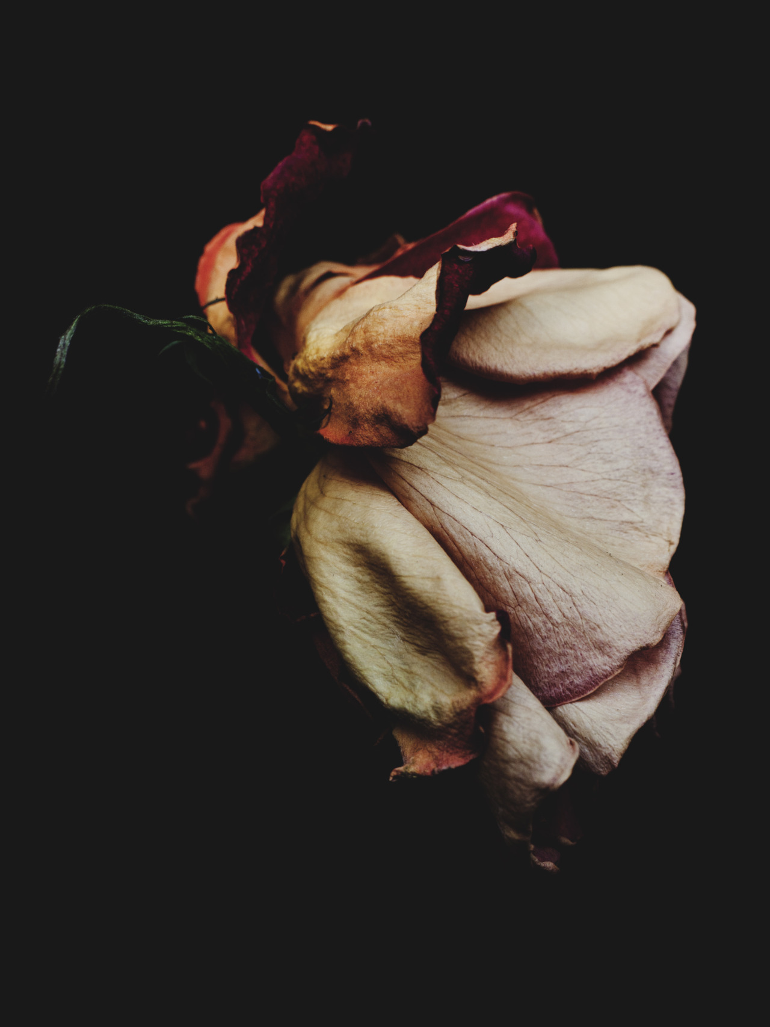
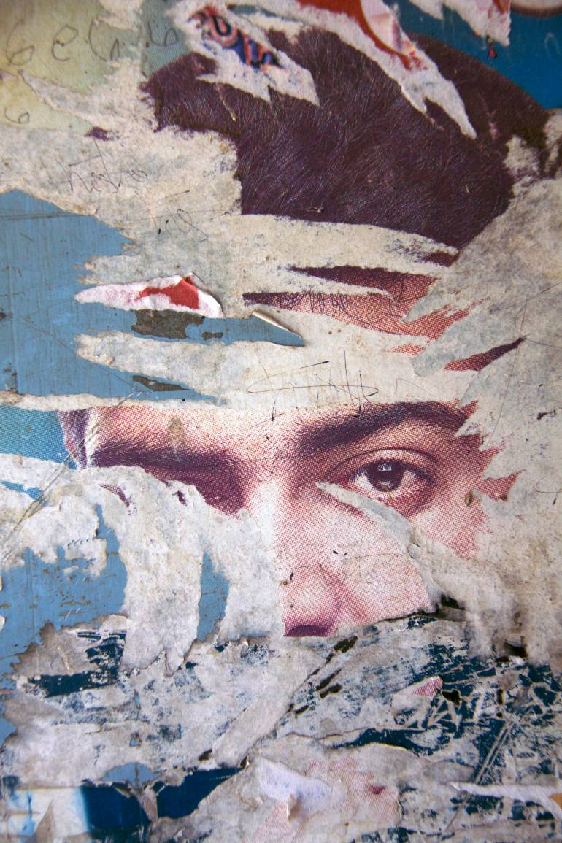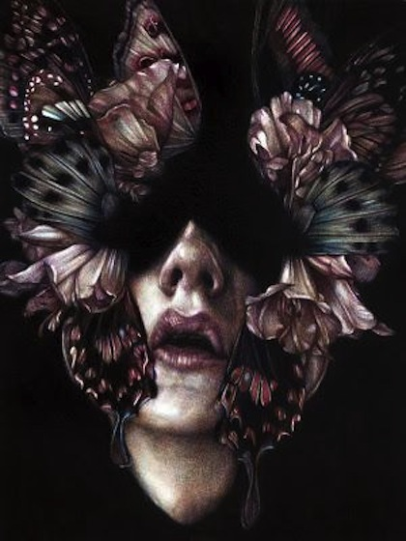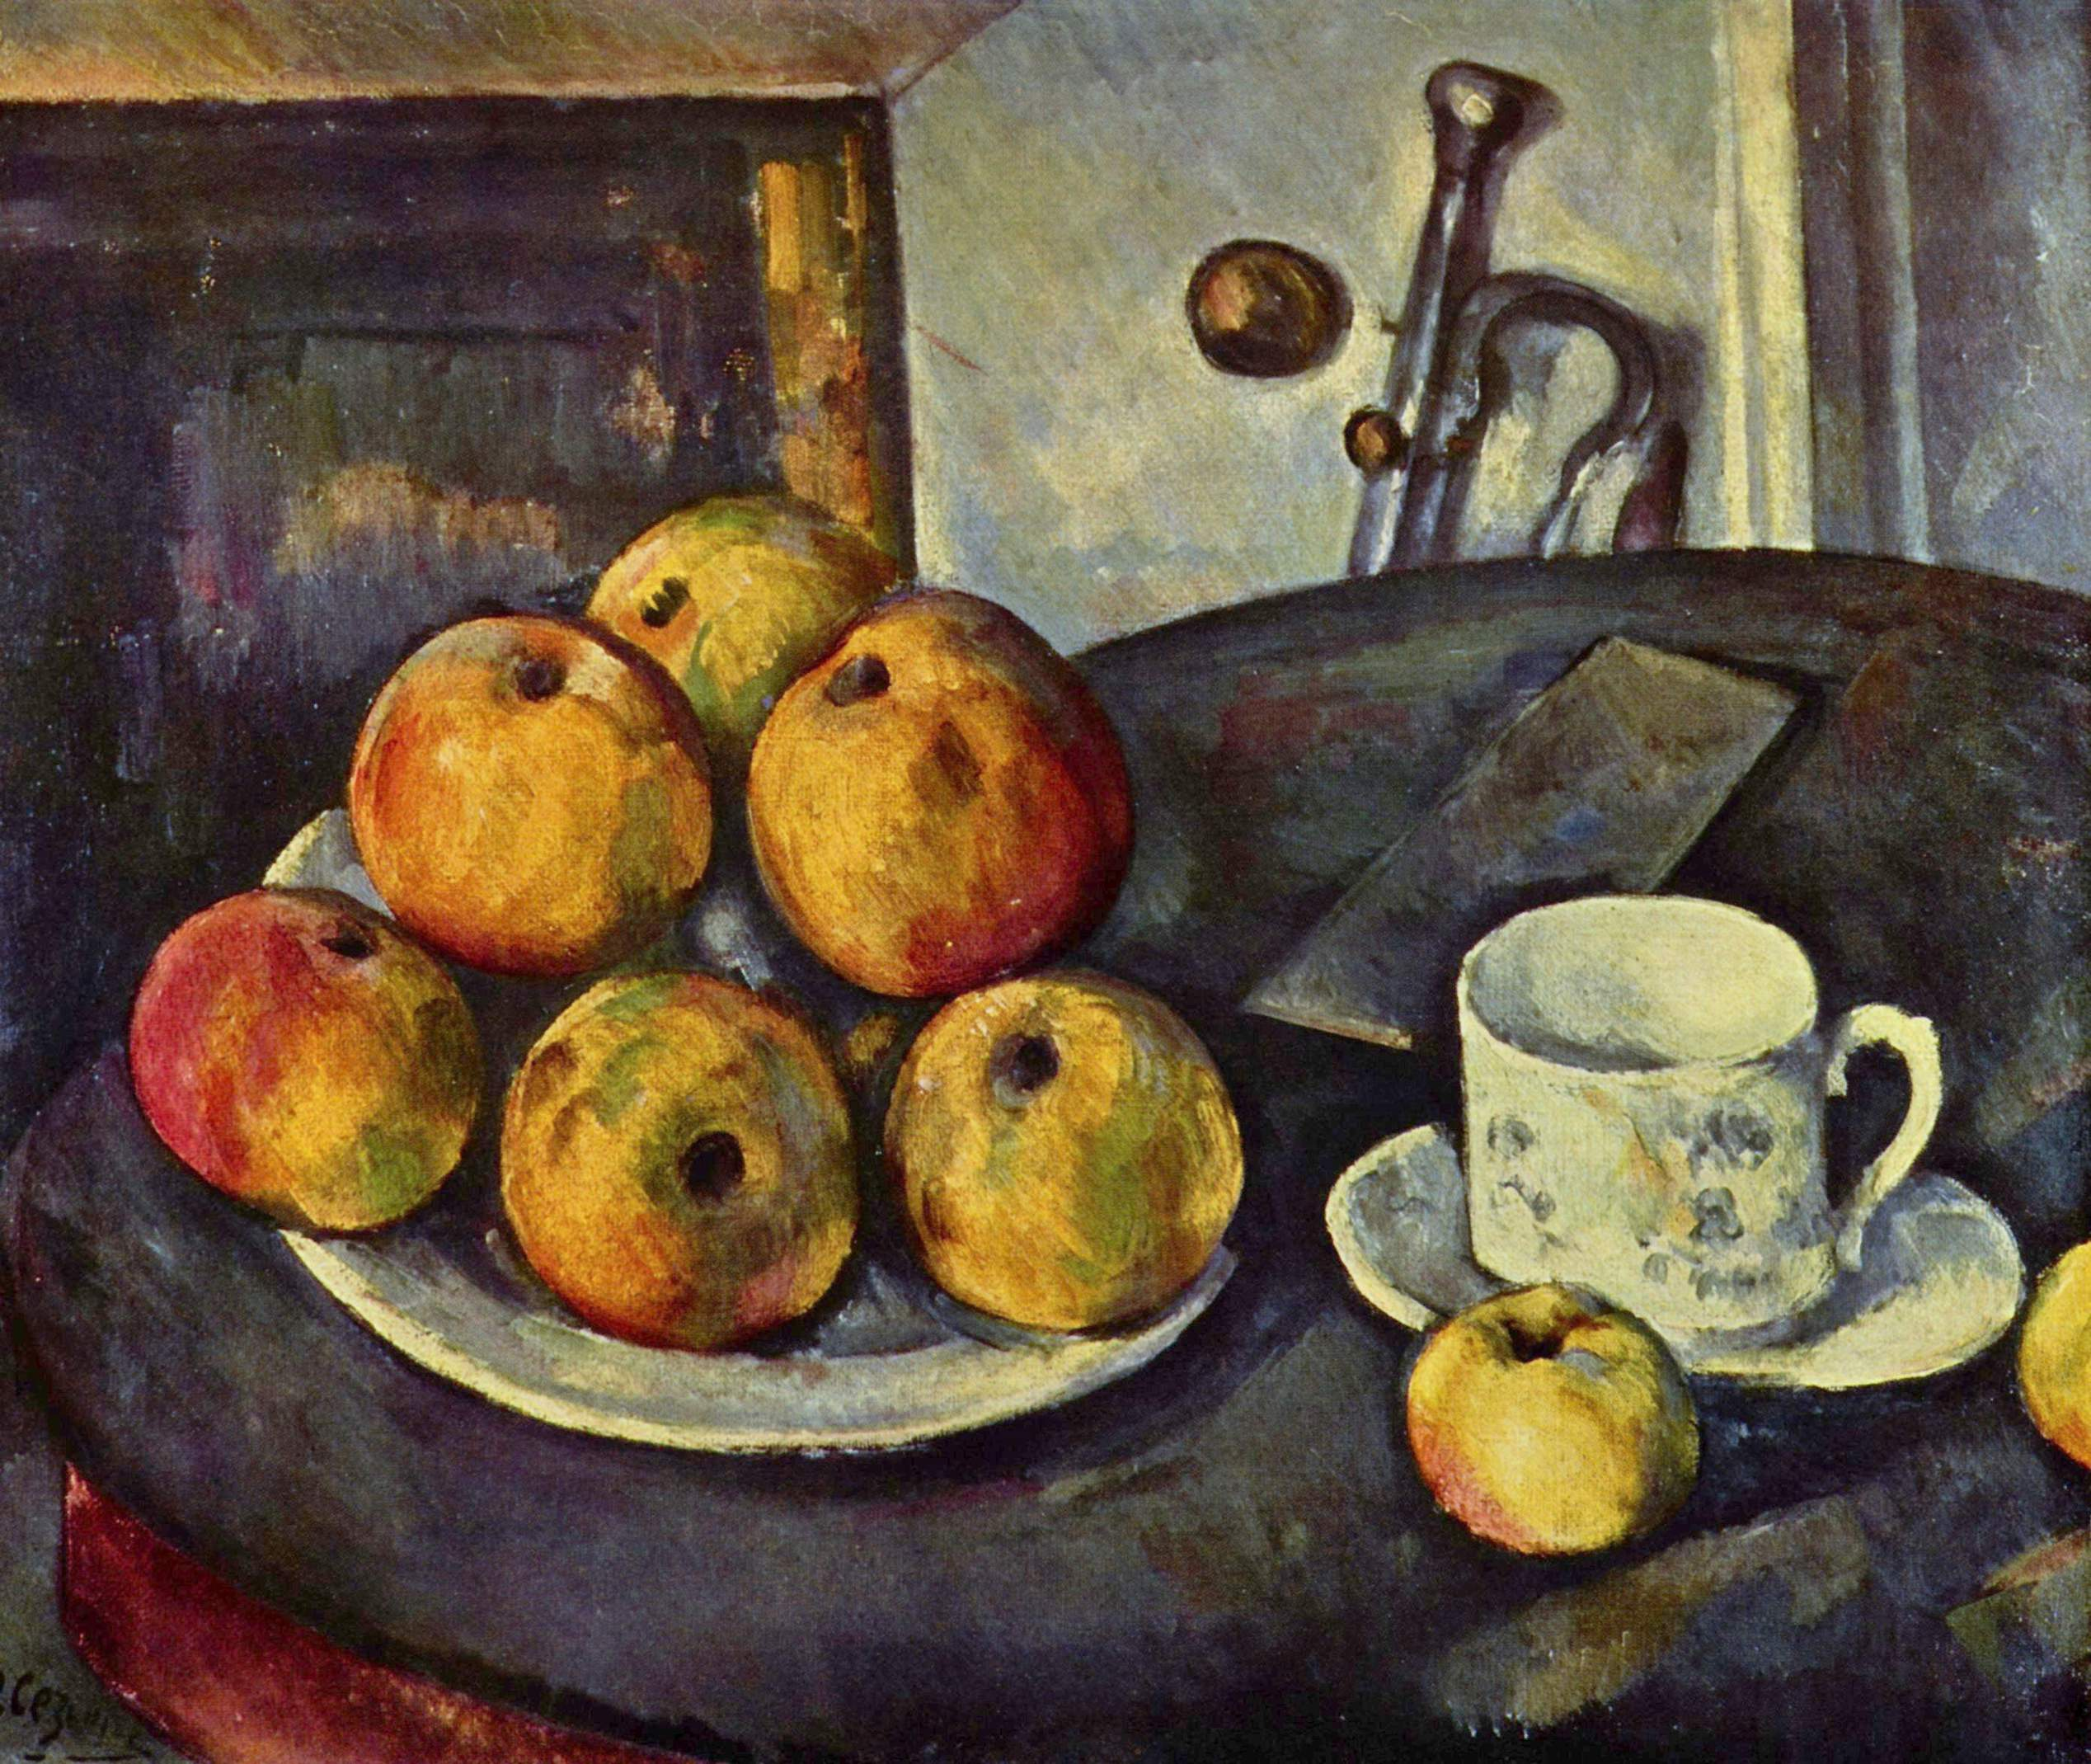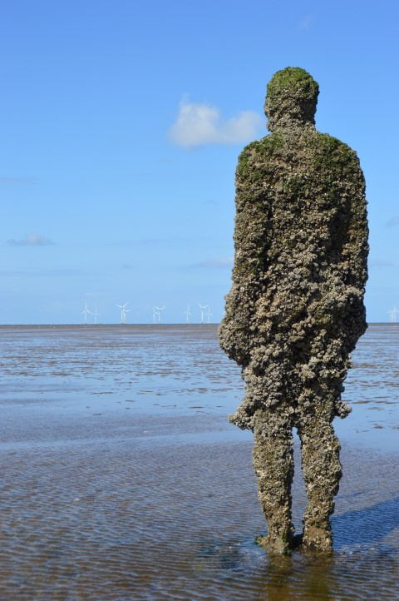
Task 1 | Specialist Pathways  People who work in art and design have many specialist skills. The path they follow to gain these skills includes learning in very different areas of art and design.  Research Growth and/or Decay. Collect primary and secondary imagery to help you. This could be in the form of spider diagrams, drawings, rubbings, photos, a Pinterest page, annotations etc. Research artists and designers who have used similar themes as their inspiration.  Using your developmental research into Growth and/or Decay, you will now create at least 4 experimental outcomes from the following specialist pathways: (You are encouraged to create more outcomes using other specialist pathways if you can)  - Drawing  - Photography  - Animation (work individually or collaboratively if you choose)  - Collage  Each pathway should respond to the brief and health and safety should be documented
Evidence you must produce for this task | A sketchbook of which should contain:  - Research in to Growth and/or Decay  - Experimental outcomes of at least 4 specialist pathways  - Health and safety documented
Criteria covered by this task:
To achieve the criteria you must show that you are able to: |  |  | Unit |  | Criterion reference
Select and apply at least four specialist materials, techniques, equipment and processes safely to create outcomes that meet the requirements of client briefs. |  |  | 1 |  | 2A.P1
Consistently select a diverse range of specialist materials, techniques, equipment and processes to create effective outcomes that meet the requirement of client briefs. |  |  | 1 |  | 2A.M1
Independently select a diverse range of specialist materials, techniques, equipment and processes to create imaginative outcomes that meet the requirements of client briefs. |  |  | 1 |  | 2A.D1
Task 2 | Final Growth and/or Decay Piece  Now that you have experimented with at least 4 specialist pathways it’s time to develop your ideas for your final piece. You must show experimentation with specialist materials, techniques, equipment and processes.  Consider formal elements of line, tone, pattern, texture, form, colour and scale in your ideas. These are very important within each of the specialisms you have chosen to work in.  Choose appropriate materials and think about how you are going to make it. What scale will it be? How will it be presented in the annual Tallis exhibition? Will you be able to meet the client brief if you produce well finished outcome? You will be working to constraints of time/materials and budgets as any artists or designer has to.  Evaluate your final outcome in response to the brief.
Evidence you must produce for this task | A completed sketchbook recording the progress of your work.  Your final Growth and/or Decay piece.  An evaluation of your final piece in response to the brief.
Criteria covered by this task:
To achieve the criteria you must show that you are able to: |  |  | Unit |  | Criterion reference
Select and use specialist materials, techniques, equipment and processes to record a minimum of four formal elements to meet the requirements of specialist briefs |  |  | 1 |  | 2B.P2
Competently select and use specialist materials, techniques, equipment and processes to effectively record a diverse range of formal elements to meet the requirements of specialist briefs |  |  | 1 |  | 2B.M2
Confidently develop and exploit the characteristics of specialist materials, techniques, equipment and processes to record a creative and diverse range of formal elements to meet the requirements of specialist briefs |  |  | 1 |  | 2B.D2
Sources of information | References  Relevant artists and designers:  Marco Mazzoni Tracey Emin’s tapestries  Vanitas Marc Quinn (self and Alison lapper, flower sculptures)  Damien Hirst Andy Goldsworthy  Ron Mueck Ai Weiwei  Van Gogh skeleton Francis Bacon  Gustav Klimt Anthony Gormley  Cezanne Bill Viola  Otto Dix Chris Ofili  Edvard Munch Cornelia Parker  Georgia O’keefe Dan Flavin  Giacometti Picasso  Jenny Saville Stephen Wiltshire  John Stezaker Wilhelm Sasnal  Kate Malone Florian Nicolle  Gabriel Orozco Grason Perry  Relevant books:  Patrick Bade (2008) 1000 Sculptures of Genius  Gombrich, EH (1950) ‘The Story Of Art’ – Chapter 27: Experimental Art  Terry Jones (2009) 100 Contemporary Fashion Designers  Glenn Halper (2010) A Sculpture Reader: Contemporary Sculpture Since 1980  Jac Scott (2003) Textile Perspectives in Mixed-Media Sculpture  Relevant Websites:  www.craftscouncil.org.uk  www.skillset.org  www.sculpture.org/  www.tate.org.uk/collections/glossary/definition.jsp?entryId=267  www.guardian.co.uk/artanddesign/  www.jennyfordsculpture.com/  www.textilescapes.co.uk/portfolio2.html  pinterest.com
If you have not achieved the Level 2 criteria, your work will be assessed to determine if the following Level 1 criteria have been met.
To achieve the criteria you must show that you are able to: |  |  |  | Unit |  | Criterion reference
Use at least two materials and techniques to create outcomes in response to client briefs, using equipment and processes safely |  |  |  | 1 |  | 1A.1
Explore specialist materials, techniques, equipment and processes to record a minimum of two formal elements |  |  |  | 1 |  | 1B.2

