Thomas Tallis School

Assignment title | ‘Journeys’ 2D Artwork
Assessor
Date issued
Duration (approx..)
Hand in Date |  | Assessment Date
Qualification suite covered | BTEC NQF Level 2 First Award in Art and Design
Units covered | Unit 3: Communicating Ideas in 2D
Learning aims covered | Learning aim A: explore 2D visual language and working practices  Learning aim B: investigate how artists, craftspeople and designers communicate in 2D.  Learning aim C: Communicate ideas using 2D knowledge and skills in response to a brief
Scenario | Greenwich Council is commissioning you to develop and produce 2D artwork on the theme of ‘Journeys’ to be displayed in Kidbrooke Station. Your artwork should help to celebrate the regeneration of Kidbooke Village and surrounding area. You should consider what would be a suitable size and position for placement of the artwork. This should be a mixed media piece and could include drawing, printing and or collage.
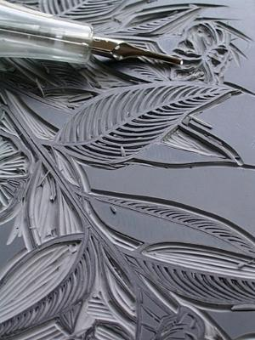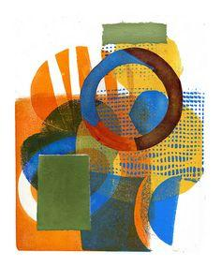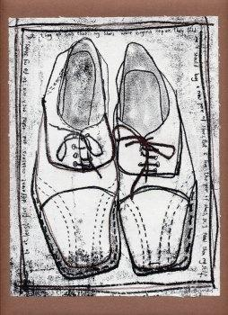

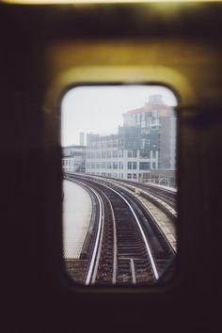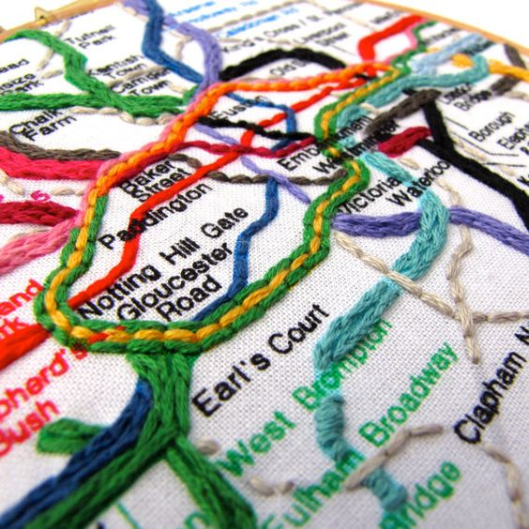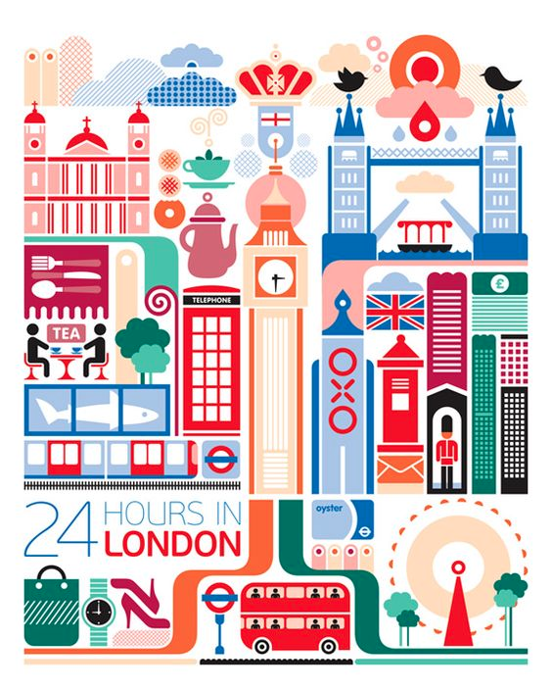
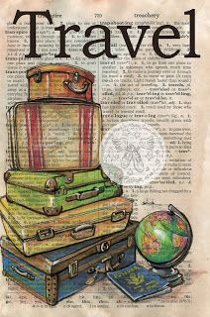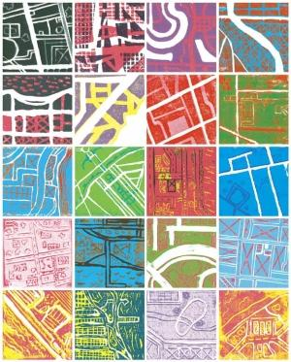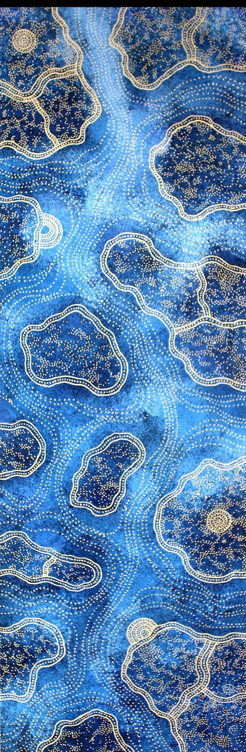

Task 1 | Explore Printmaking and Printmakers  Start by exploring 2D printmaking materials, techniques and processes. Investigations should include mono printing, lino printing, etching, collograph, mark making, rubbings, collage, textures, water based ink, oil based ink, colour, layering, paper cutting, drawing, etc  Compare advantages and disadvantages of using different materials, techniques and processes eg colour, strength of plate, repetition or one off, water based or oil based process, block or fine detail, accuracy etc. Annotate your results, discuss the properties and characteristics of each process.  For each process you have explored, investigate a 2D practitioner who uses a similar material or technique. Annotate their use of 2D materials, techniques and ways of communicating.  Compare and contrast the works of 4 2D practitioners illustrating their different approaches  You should demonstrate safe working practice with materials (e.g. white spirit, cutting tools, scissors, scalpels, glue gun, stapler etc)  You will present your samples to the class, explaining how your ideas developed from your research into artists, and what materials, equipment and techniques you have used.
Evidence you must produce for this task | A sketchbook of 2D developmental work which should contain experiments of different techniques, processes and investigations into a range of 2D practitioners  2D experiments into a range of materials, techniques and processes  A verbal presentation of the above work to the class, reviewing your discoveries so far and how your ideas could be developed further
Criteria covered by this task:
To achieve the criteria you must show that you are able to: |  |  | Unit |  | Criterion reference
Apply 2D visual language using materials, equipment and techniques, observing and recording safe working practices. |  |  | 3 |  | 2A.P1
Apply 2D visual language, selecting and using a diverse range of materials, equipment and techniques effectively and with consistency. |  |  | 3 |  | 2A.M1
Apply 2D visual language, combining and using a diverse range of materials, equipment and techniques, creatively and imaginatively. |  |  | 3 |  | 2A.D1
Describe four of the skills and associated materials, techniques and processes required by practitioners working in 2D. |  |  | 3 |  | 2B.P2
Select and present effective investigations into a diverse range of 2D practitioners, explaining how they communicate their ideas. |  |  | 3 |  | 2B.M2
Select and present in-depth investigations into a diverse range of 2D practitioners, analysing how they communicate their ideas. |  |  | 3 |  | 2B.D2
Select and present examples of work by at least four 2D professional practitioners, illustrating their different approaches. |  |  | 3 |  | 2B.P3
Task 2 | Final Piece  Research into “Journeys” and collect images and inspiration symbolising a journey.  Create an observational drawing of your chosen journey symbol. Produce a range of prints of your chosen symbol. You will need to consider what printmaking process, paper, ink and colours would be suitable for your idea. Document your development throughout using photographs and annotations. Note any change of ideas and any difficulties you have overcome.  Identify your most successful print. Photocopy this 8 times onto thick cartridge paper. Cut, manipulate, experiment and arrange your prints developing at least 4 ideas for your final mask piece. You will need to consider how it will sit on the face/head, health and safety eg eye holes and breathing holes, how you will attach and construct the final piece  Produce your most successful idea
Evidence you must produce for this task | A completed sketchbook recording the progress of your work.  Your final printed mask  An evaluation of your final piece and use of 2D materials, techniques and processes
Criteria covered by this task:
To achieve the criteria you must show that you are able to: |  |  | Unit |  | Criterion reference
Communicate ideas using 2D knowledge and skills to generate visual work that meets the requirements of a brief, observing and recording safe working practices. |  |  | 3 |  | 2C.P4
Select and use 2D materials, equipment and techniques to generate a diverse range of visual work that effectively meets the requirements of a brief. |  |  | 3 |  | 2C.M3
Use a diverse range of 2D materials, equipment and techniques to generate a diverse range of visual work that imaginatively meets the requirements of a brief. |  |  | 3 |  | 2C.D3
Record the progress of own work and use of 2D methods. |  |  | 3 |  | 2C.P5
Effectively explain the progress of own ideas and review use of 2D methods. |  |  | 3 |  | 2C.M4
Analyse and evaluate the progress of own ideas and use of 2D methods. |  |  | 3 |  | 2C.D4
Sources of information | Relevant artists:  Popova, Otto Dix, Van Gogh, Hundertwasser, Albrecht Dürer, Henri de Toulouse-Lautrec, Henri Matisse, Roy Lichtenstein, Pablo Picasso, M Lee, Edvard Munch, Andy Warhol, Cas Holmes.  Books  Dawson J – The Complete Guide to Prints and Printmaking Techniques and Materials (Bookthrift Co, 1983) ISBN 978-0896730953  Printing with Traditional Art Materials (Watson-Guptill, 2004) ISBN 978-0823013425  Hughes d’Arcy A – Printmaking: Traditional and Contemporary Techniques (Rotovision, 2009) ISBN 978-2940361533  Harrison, H., The Encyclopedia of Drawing Techniques, Search Press, 2004 (ISBN 978-0-7624-1894-7)  Sokol, D., 1,000 Artist Journal Pages: Personal Pages and Inspirations, Rockport Publishers Inc, 2008 (ISBN 978-1-59253-412-8)  Gombrich, EH (1950) ‘The Story Of Art’ – Chapter 27: Experimental Art  Stobart J – Printmaking for Beginners (A&C Black, 2005) ISBN 978-0713674637  Websites  www.artshow.com/resources/printmaking.html  www.connectworks.co.uk/printeurope  www.eastlondonprintmakers.co.uk  www.edinburgh-printmakers.co.uk  www.monoprints.com  www.princetonol.com/groups/iad/lessons/middle/prints.htm  www.printmaker.co.uk  www.printmaker.co.uk/pmc/index.php  www.printmaking.org.uk  www.worldprintmakers.com/english/pmtechni.htm  www.creative-choices.co.uk/industry-insight/inside/design  www.tate.org.uk  www.guardian.co.uk/artanddesign/art  pinterest.com  www.nationalgallery.org.uk  http://www.saatchigallery.com
If you have not achieved the Level 2 criteria, your work will be assessed to determine if the following Level 1 criteria have been met.
To achieve the criteria you must show that you are able to: |  |  |  | Unit |  | Criterion reference
Apply 2D visual language with a limited range of materials, equipment and techniques using safe working practices. |  |  |  | 3 |  | 1A.1
Identify how artists, craftspeople and designers communicate in 2D. |  |  |  | 3 |  | 1B.2
Present at least two examples of 2D professional practitioners, identifying the chosen artists, craftspeople and designers. |  |  |  | 3 |  | 1B.3

